Common Security Module and
User Provisioning Tool 5.0
User’s Guide Update
11/02/2012

[Type the abstract of the document here. The abstract is typically a short summary of the contents of the document. Type the abstract of the document here. The abstract is typically a short summary of the contents of the document.]

Contents
Document Change History 3
1. Purpose 3
2. Configurable User Provisioning Operations 4
2.1. Background 4
2.2 Operation Procedures 5
Step One: Create Special PROTECTION_ELEMENT 5
Step Two: Create Special PROTECTION_GROUP 6
Step Three: Assign PROTECTION_ELEMENTs into PROTECTION_GROUPs 7
Step Four: Associate User, Protection Group, and Role 8
Step Five: Protect UPT operations 10
2.3 Migration Consideration 12
3. Instance Level Security 12
3.1 Overview of Functionality 12
Direct Instance Level Security 12
Cross Dependent Instance Level Security 12
Instance Level Security at User or Group Level 13
3.2 Design Consideration 13
3.3 Operation Procedures 13
Upload an Application File 13
Create Instance Level Security Filter 14
Create Protection Element 15
Assign Protection Elements into Protection Group 15
Use Instance Level Security 16
4. NIH Password Policy 16
Change Password 16
Deactivate User 17
Configurable Password Management 17
Account lockout threshold setting 18
Appendix A. Special PROTECTION_ELEMENT for Configurable User Provisioning Operations 18
Appendix B Default PROTECTION_GROUP for Configurable User Provisioning Operations 21

Document Change History
Version | Date | Changed by | Description
1.0 | 06/12/2012 | Eugene Wang | Initial draft
1.01 | 11/02/2012 | Eugene Wang | Synchronize with GUI screenshots
1.02 | 11/29/2012 | Mahidhar Narra | Add password policy section

Purpose
This document provides modification of User’s Guide for Common Security Module (CSM) and User Provisioning Tool (UPT) 5.0 version. It lists step-to-step instructions for user to perform CSM/UPT functionalities implemented by this version. This version addresses functional improvements as well as usability improvements.
Functional Improvements include:
- Configurable user provisioning operations
- User account activation.
- NIH Password Policy enforcement.
- Configurable password management.
Usability Improvements include:
- Account lockout threshold setting.
- Instance Level Security
Instead of providing design details for all features of 5.0 versions, this draft document focuses on Configurable User Provisioning Operations, other feature maybe added in later or described with separated document.

Configurable User Provisioning Operations

2.1. Background
As default, UPT Admin users are granted full scope of access permissions to all the seven UPT locations/elements: user, group, protection element, protection group, privilege, role, and instance level filter. They are able to perform all operations over these elements such as create, update, delete, or setup association between these objects. Figure 2.1 is the UPT operation menu bar with all buttons being activated.
Figure 2.1. Full UPT Operation Menu Bar
UPT provides its user provisioning capabilities using CSM API. Similarly, an application can provide the same kind of user provisioning capabilities as using the same set of CSM API. The following two equivalent approaches could achieve the goal of UPT capabilities:
- Implement CSM API within its application
- Use UPT as supporting component
Problems arise if an application adopts a mixture of the two above approaches since they use the same set of CSM API and share the same user provisioning database schema. For example, UPT provides capability to add and update a user into CSM RDBMS schema. If an application implementing CSM API, it would have same capability to add and update a user into the same RDBMS schema. Ideally, it would prefer to remove or hide one or more user provisioning features from default UPT if an application implements these features using CSM API.
The Configurable User Provisioning Operations resolves these problems allowing an application to limit user to access these UPT operations. CSM may grant or exclude user from one or one group of UPT operations. If a user is excluded to access a UPT operation, UPT will disable the corresponding menu button if that user login. Figure 2.2 shows Configurable UPT Operation Menu Bar with disabled “Role” and “Instance Level” operations.
Figure 2.2 Configurable UPT Operation Menu Bar

These Configurable User Provisioning Operations are implemented with changes in two areas:
- CSM API Changes – check user’s permission to perform User Provisioning Functionalities. These changes do not involve end user’s actions.
- UPT Operation Procedure Changes – allow Admin users configure UPT to enable/disable some User Provisioning Functionalities for particular user group.

2.2 Operation Procedures
An Admin user can configure its UPT application to enable/disable some User Provisioning Functionalities for particular user group. The following section describes these operations step-by-step.

Step One: Create Special PROTECTION_ELEMENT
The Configurable UPT Operation features leverage existing CSM authorization schema. It depends on 28 special records in table CSM_PROTECTION_ELEMNT to grant user’s permission to each User Provisioning Operation. Each CSM_PROTECTION_ELEMENT record maps to one User Provisioning Operation. For details of these special records, please refer Configurable UPT Design 5.0.
When a new application is registered to CSM super application, system creates all these 28 CSM_PROTECTION_ELEMENT records. End user is not allowed to modify or delete any of these records. If one record is modified, the corresponding User Provisioning Operation may not work properly; If one record is deleted, Admin user will not be able to control its corresponding User Provisioning Operation. Figure 2.3 partially lists these 28 default Protection Elements.
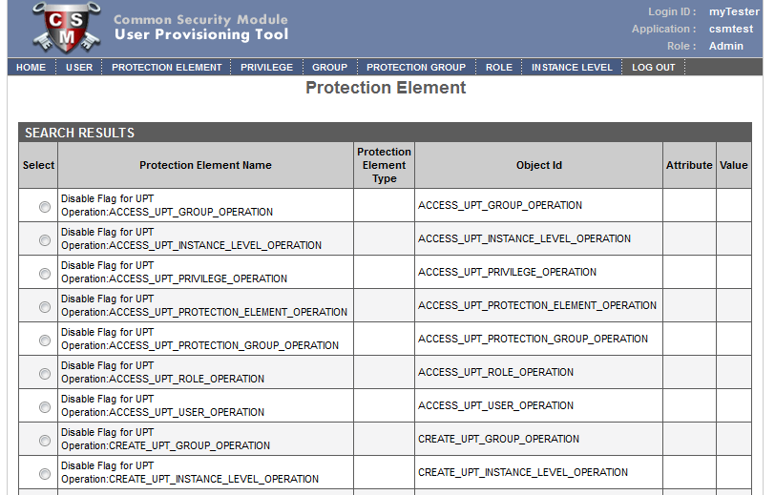
Figure 2.3 Default Protection Elements for Configurable UPT Operations

Step Two: Create Special PROTECTION_GROUP
As it register a new application, system also creates two default records in table CSM_PROTECTION_GORUP. Figure 2.4 depicts information of these two default Protection Groups.
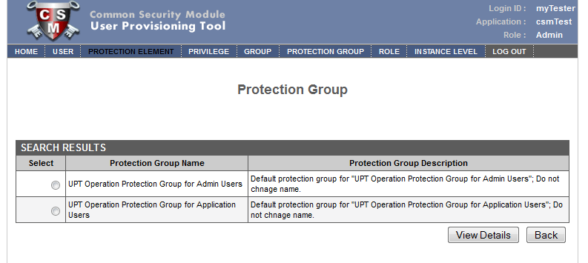
Figure 2.4 Default Protection Groups
- UPT Operation Protection Group for Admin Users– This Protection Group is associated with any Disable Flags of UPT operation for admin users. As default, it is empty and admin user is able to perform all UPT operations.
- UPT Operation Protection Group for Application Users – This Protection Group is associated with any Disable Flags of UPT operation for application users. As default, it is empty. An admin user can associate it with any PROTECTION_ELEMENT listed in table 5.1 to deny application user to perform any UPT operation.
Alternatively, an Admin user can create any PROTECTION_GROUP as long as the user has privilege of CREATE_CSM_PRTOECTION_GROUP_OPERATION.

Step Three: Assign PROTECTION_ELEMENTs into PROTECTION_GROUPs
After the first step, all these PROTECTION_ELEMENT are independent from any PROTECTION_GROUP. An Admin Users, as long as who has permission to perform UPT_PROTECTION_GROUP operations, can associate these special PROTECION_ELEMENT with any PROTECTION_GROUP to disable its corresponding UPT operation. Figure 2.5 shows that two flag Protection Elements are associated with one system default configurable UPT operation group: UPT Operation Protection Group for Amin Users. The associated two Protection Elements are: DELETE_UPT_PROTECTION_ELEMENT_OPERATION and UPDATE_UPT_ PROTECTION_ELEMENT _OPERATION, which disable “Protection Element” operations of “delete” and “update” respectively.
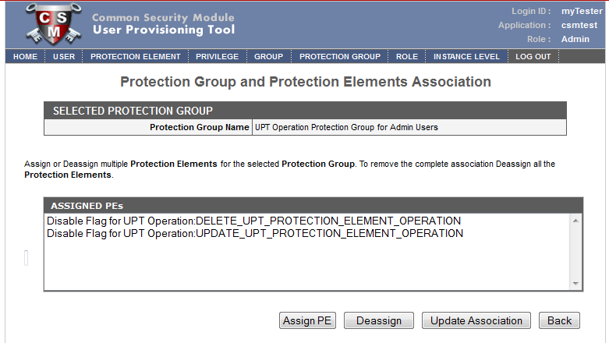
Figure 2.5 Associations Between Flag Protection Element and Protection Group
The above action is reversible. An Admin user can also de-assign any flag PROTECTION_ELEMENT from a PROTECTION_GROUP.

Step Four: Associate User, Protection Group, and Role
CSM API does not manage user’s operation privilege over each individual Protection Element. It follows navigating path as
User → Group →Role→ Privilege
and
Group →Protection Group → Protection Element
In order to retrieve associated the special configurable UPT operation flag Protection Elements for each individual user. It has to define a special Role and user Group. The Role is associated with Protection
Group, and Group is associated with interested Users. Figure 2.6 shows user Group “uptConfigDemo” is associated with Protection Group “UPT Protection Group for Admin Users”, which is assigned with Role “configurableUPT” .
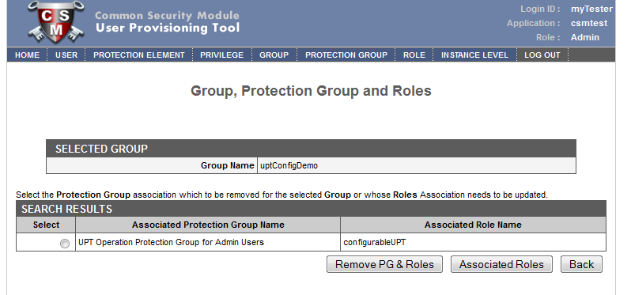
Figure 2.6. Group, Protection Group and Role Association

Figure 2.7 shows Group “uptConfigDemo” is associated with two flag Protection Element for configurable UPT operations “DELETE_UTP_PROTECTION_ELEMENT_OPERATION” and “UPDATE_UTP_PROTECTION_ELEMENT_OPERATION”
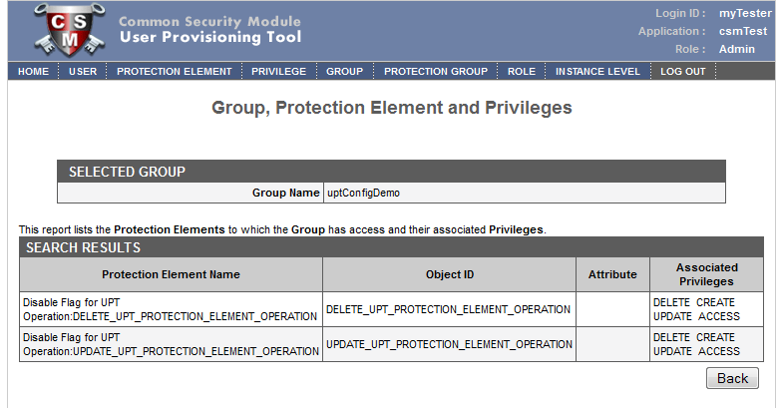
Figure 2.7 Group, Protection Element and Privilege Association
Figure 2.8 shows User “myTester” is assigned into Group “uptConfigDemo”. The setting would enable CSM API to grant required configurable UPT operations for User “myTester”.
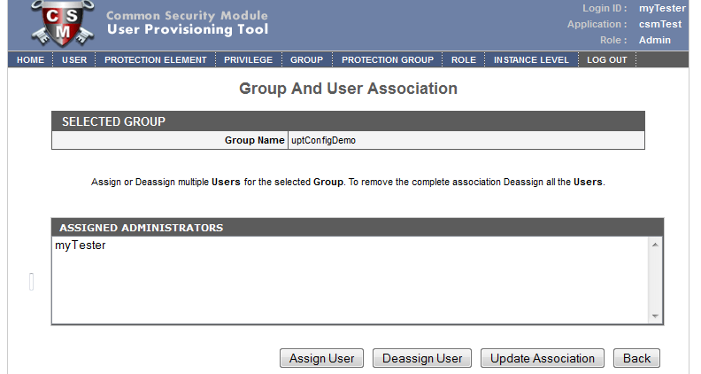
Figure 2.8. Group and User Association

Step Five: Protect UPT operations
When user login, system checks user’s association permission to perform any of 27 predefined UPT operations. It are grants a user’s permission for configurable UPT operation based on access privilege to these the 28 predefined flag Protection Elements. Use setting in step one, two, three, and four, Figure 2.9 shows that User “myTester” has privileges to create new Protection Element and access existing Protection Elements.
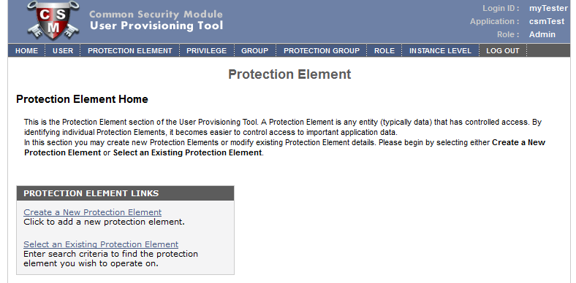
Figure 2.9 Provision Protection Element
Figure 2.10 shows User “myTester” is removed the privileges to delete or update an existing Protection Element.
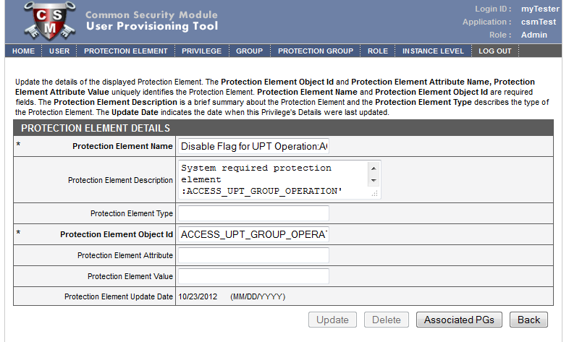
Figure 2.10 Details of Protection Element

2.3 Migration Consideration
The Configurable UPT Operation features require updates both database and operation procedure. The database updates include creation flag Protection Element record and Protection Group records for all the UPT operations. UPT application has modified to create all required data when it registers a new application. For existing application, these special records should be created from frontend with predefined names by Admin users following operation procedure defined in section 2.2.
The Configurable UPT Operation features are new for UPT extending functionalities of earlier versions. An application can ignore all these features by configuration operations. It an application does that users will not feel any impact of these features.

Instance Level Security
Instance Level Security allows filtering of object instances directly at the database level. The following sections revise CSM/UPT 4.2 User’s Guide.

3.1 Overview of Functionality
CSM/UPT 5.0 improve Instance Level Security features by enabling user to setup filter on either particular instance or the instance of its associated objects. It can apply predefined filter to either a user or a user group.

Direct Instance Level Security
Direct Instance Level Security depends on the instance object itself. It defines access privilege to a particular object based on the value of one of the object’s attributes.
For example, out of 456 patients in the patient table, user ABC has access to a specifically 28 patients from the same clinic.
In this scenario, if a filter is set on “clinic id” attribute of patient object, a query could be fired on the patient table that returns those 28 records with the same clinic to user ABC.

Cross Dependent Instance Level Security
Cross Dependent Instance Level Security depends on some other object(s) associated with the instance object. It defines access privilege to a particular object based on its association to some other objects. It filters records of the queried tables based record in other table to which the security is assigned.
For example, a lab result record is always associated with a study record. A user or group can access those lab results only if have permission to access the associated study.
In this scenario, if a filter is set on an attribute of study object, a query could be fired on the lab result table that returns those lab result records associated with an accessible study record. Practically, there can be thousands of lab results whereas the number of studies could be less than 100. It is presumed that the assignment and management of security is much easier for the studies as they are less in number.

Instance Level Security at User or Group Level
Once an Instance Level Security filter is defined, it can apply at user level, group level, or both. An Admin user can provision its operation level using UPT. No matter applies to which level; the same filter always returns the same results to client.

3.2 Design Consideration
CSM implements Instance Level Security filters by utilizing the Hibernate Filter capability. These filters are implemented as filtering queries or filtering criteria. The filtering queries approach injects filters to the actual business queries. When a class is queried, the filters are appended to the actual business query directly by Hibernate. The filtering criteria approach associates query criterion with each particular persistent object. When a class is queried, the associated query criterion is executed.
CSM enable user provision Instance Level Security filters through UPT tool. User can configure these filters as either Direct Dependent or Cross Dependent. When user defines an Instance Level Security filter, CSM creates associated filter queries and persist it into CSM database. CSM also allows user to edit filtering queries associated with a filter object. However, CSM generates filtering criteria\ on-fly. It converts a filter object to a filtering criterion at runtime.

3.3 Operation Procedures
UPT web page provides a menu tab for provisioning Instance Level Security. It allows user configure filters for various classes in an application. Once the filters are configured, an Admin can create Protection Elements for these filter objects. The Protection Elements control access privilege of users or groups to their associated filters. The following sections provide a workflow for provisioning Instance Level Security.

Upload an Application File
The first step is to upload Hibernate files along with the domain objects. This file should be a valid java archive with following:
- Hibernate Configuration File – with database connection information.
- Hibernate Mapping files if not using annotations.
- Domain Objects Or Domain Objects with Hibernate Annotations.
In addition, a fully qualify hibernate configuration file name should be provided along with the files. Once the files are successfully uploaded, user is confirmed with a success message.

Create Instance Level Security Filter
After upload application file(s), user can create filters for any domain objects of the uploaded application. On the filter clause screen, perform following steps:
- Select the class for which you want to add filter.
- Once the class is selected, Filter Chain drop-down list is automatically populated with its associated classes.
- If you want to provision a Direct Instance Level Security,
- Select the class itself from the Filter Chain drop-down list
- Click Done.
Alternatively, if you want to provision a Cross Dependent Security,
- Select the associated class from the Filter Chain drop-down list.
- Drill down the class hierarchy by clicking the Add button located in the Filter Chain section of the Filter Clause Details form.
- System brings the associated child classes.
- Select final class on which the security for the class is dependent
- Click Done.
The following two steps select the filtering attribute of the select filtering class. It applies to either Direct Instance Level Security or Cross Dependent Instance Level Security
- The attribute list is populated with the attributes from the last class in the filter chain.
- Select the attribute on whose value the user will be granted access.
Optionally, you can also provide an alias for the target class name and attribute. This alias will replace their corresponding target class name or attribute name in following steps of creating Protection Element for the defined Instance Level Security filter.
After everything is selected, click Add at the bottom of the filter form. As a filter is created, the filter and its associated filtering SQL statements are persisted in to database while the filtering SQL statements are displayed back to user.
Depending on whether the Instance Level Query Performance Enhancement feature is enabled for the secured object and attribute, the filtering SQL statements are generated differently.
If the instance level security query performance enhancement feature is enabled and an 'active' entry is available in the CSM_MAPPING table, the filter generation process also create temporary Instance tables and views.
The generated SQL statements for User level filtering and Group level filtering are editable to users if they want to optimize it further. The generated SQL for User will be used if instance level security is being done at the user level. The generated SQL for Group will be used when instance level security is being doing for group level.

Create Protection Element
Once the security filters have been created, you can create Protection Elements associated with these filter objects. These Protection Elements provision users or groups to access the actual filters. The table below provides descriptions of the Protection Element fields that must be populated when creating a Protection Element.
Field Name | Description
Protection Element Name | Distinct name to identify the Protection Element
Protection Element Description | Description of the Protection Element
Protection Element Type | Optional
Protection Element Object Id | This is the unique identifier linking Protection Element with its corresponding Filter Clause. If Filter Clause is a self dependent filter, it should be the target class name on which the security of the master class depends. If Filter Clause is a cross dependent filter, it should be the value of Filter Chain. In both cases, if an alias class name is used, then the alias should be entered here.
Protection Element Attribute | The name of the attribute of the target class on which the security of the master class depends. If an alias attribute name is used then the alias should be entered here
Protection Element Value | The actual “filtering” value of the attribute on which user has access.
Update Date | Date when the protection element was last updated

Assign Protection Elements into Protection Group
One or more Protections elements can be assigned into a Protection Group. User or Group will access these Protection Elements and their associated CSM filters based on their Roles and Privileges.

Use Instance Level Security
CSM implements helper class for client application to invoke the capabilities of Instance Level Security: inject filtering queries with business queries, or retrieve independent Detached Hibernate criteria. For detailed information about use the helper class, please refer Programmer’s Guide documents.

4. NIH Password Policy

Change Password
The UPT application will redirect to the change password screen when the user password is expired or the user is logs in for the first time after being created. The page will collect the old password, new password and the application context for which the user belongs. The user credentials will be posted to the CSM API changePassword() method to update the new password

The figure shows the change password UI fields for the UPT web modules
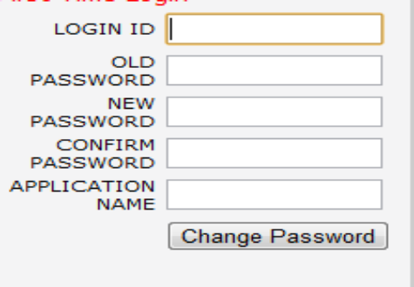

The new password should comply with the NIH password policy and should contain at least 8 characters a special character, a number and an Uppercase letter.
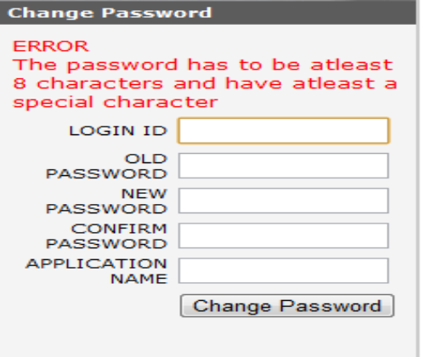
After successful login the page will be redirected to the login page.
The application user can change his user information by login to the application using UPT
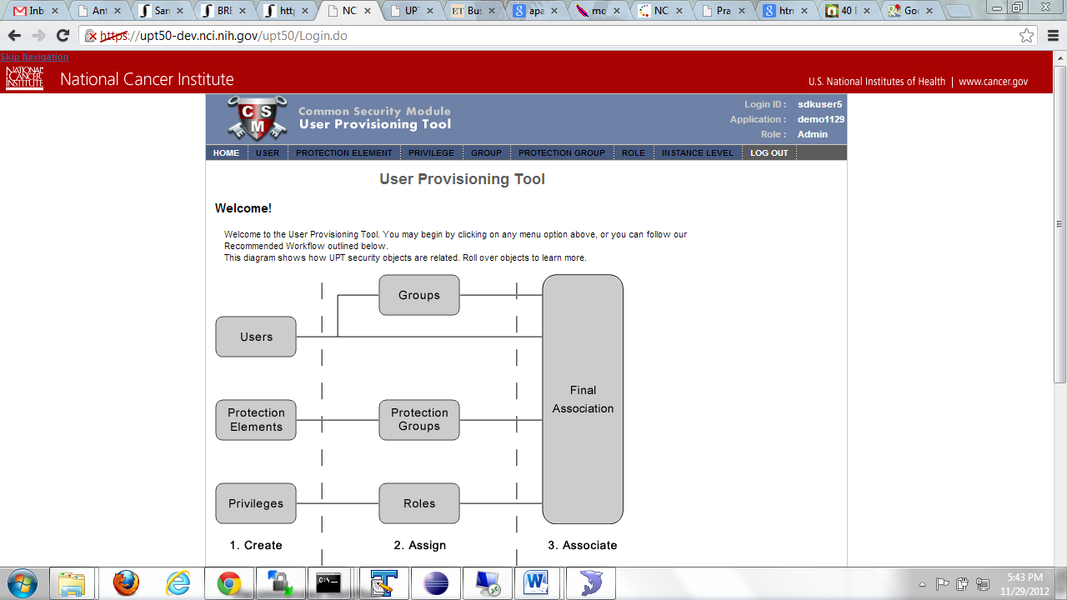

All the other links will disabled and user can click on the username on top right hand side of the page
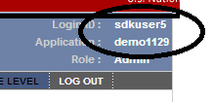
The User can change his user information and the password and click on update
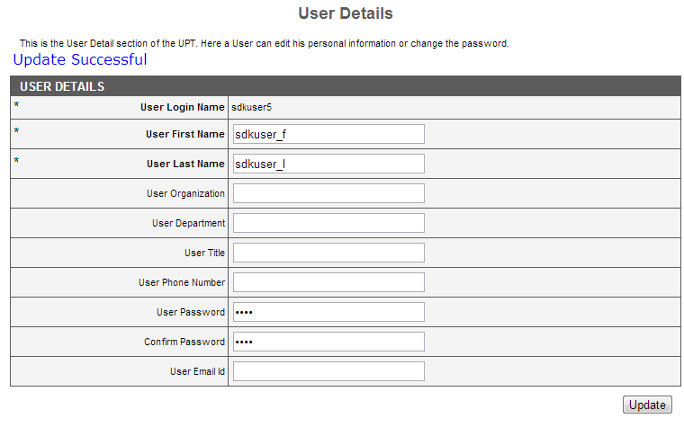

Deactivate User
The UPT application can be used to activate a deactivated user and likewise deactivate a user. The activate/deactivate feature will be provided only to admin user. When deactivated, the user can not be
authenticated and will be prompted a message with the same.

The figure shows an active flag which can be set to false to deactivate a user.
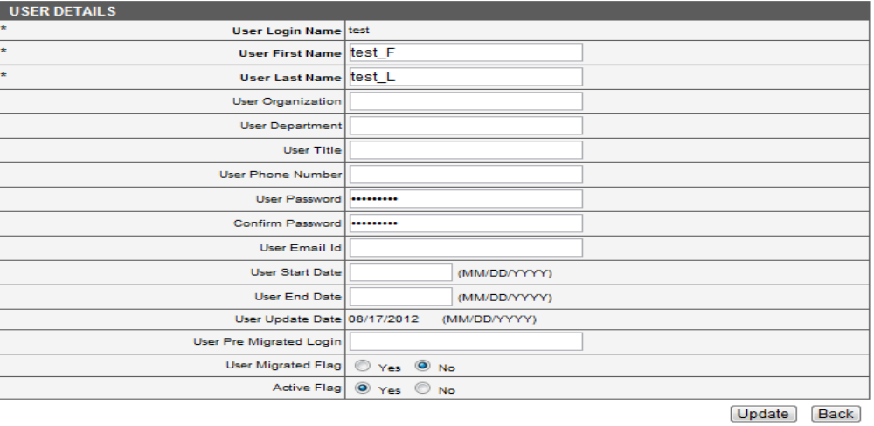

The figure shows a message when a deactivate users logs in to the system

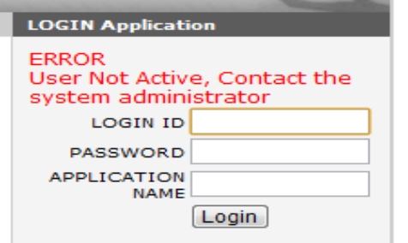

Configurable Password Management

The UPT application can be used to configure the system properties for UPT application. The system properties can be viewed and edited by the superadmin
The figure shows the system properties used by the CSM which can be viewed/updated from UPT
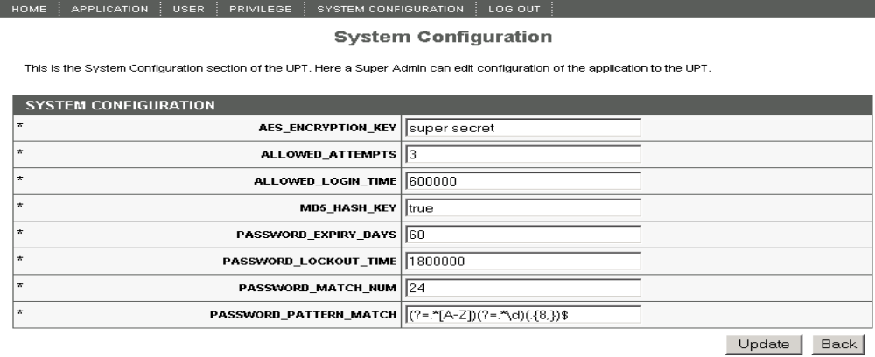

Account lockout threshold setting
The UPT application can be used to configure the Threshold values from the UPT application. The System Configuration will be enabled when the user logs in as the superadmin.
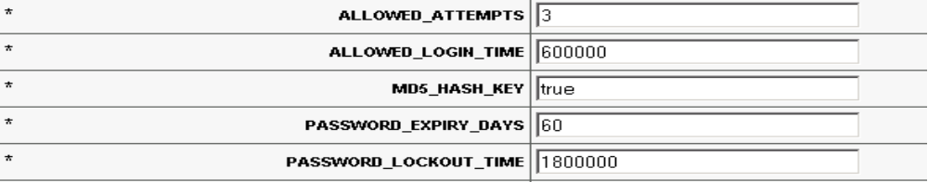

Appendix A. Special PROTECTION_ELEMENT for Configurable User Provisioning Operations
PROTECTION_ELEMENT_NAME | OBJECT_ID
Disable Flag for UPT Operation:ACCESS_UPT_GROUP_OPERATION | ACCESS_UPT_GROUP_OPERATION
Disable Flag for UPT Operation:CREATE_UPT_GROUP_OPERATION | CREATE_UPT_GROUP_OPERATION
Disable Flag for UPT Operation:DELETE_UPT_GROUP_OPERATION | DELETE_UPT_GROUP_OPERATION
Disable Flag for UPT Operation:UPDATE_UPT_GROUP_OPERATION | UPDATE_UPT_GROUP_OPERATION
Disable Flag for UPT Operation:ACCESS_UPT_INSTANCE_LEVEL_OPERATION | ACCESS_UPT_INSTANCE_LEVEL_OPERATION
Disable Flag for UPT Operation:CREATE_UPT_INSTANCE_LEVEL_OPERATION | CREATE_UPT_INSTANCE_LEVEL_OPERATION
Disable Flag for UPT Operation:DELETE_UPT_INSTANCE_LEVEL_OPERATION | DELETE_UPT_INSTANCE_LEVEL_OPERATION
Disable Flag for UPT Operation:UPDATE_UPT_INSTANCE_LEVEL_OPERATION | UPDATE_UPT_INSTANCE_LEVEL_OPERATION
Disable Flag for UPT Operation:ACCESS_UPT_PRIVILEGE_OPERATION | ACCESS_UPT_PRIVILEGE_OPERATION
Disable Flag for UPT Operation:CREATE_UPT_PRIVILEGE_OPERATION | CREATE_UPT_PRIVILEGE_OPERATION
Disable Flag for UPT Operation:DELETE_UPT_PRIVILEGE_OPERATION | DELETE_UPT_PRIVILEGE_OPERATION
Disable Flag for UPT Operation:UPDATE_UPT_PRIVILEGE_OPERATION | UPDATE_UPT_PRIVILEGE_OPERATION
Disable Flag for UPT Operation:ACCESS_UPT_PROTECTION_ELEMENT_OPERATION | ACCESS_UPT_PROTECTION_ELEMENT_OPERATION
Disable Flag for UPT Operation:CREATE_UPT_PROTECTION_ELEMENT_OPERATION | CREATE_UPT_PROTECTION_ELEMENT_OPERATION
Disable Flag for UPT Operation:DELETE_UPT_PROTECTION_ELEMENT_OPERATION | DELETE_UPT_PROTECTION_ELEMENT_OPERATION
Disable Flag for UPT Operation:UPDATE_UPT_PROTECTION_ELEMENT_OPERATION | UPDATE_UPT_PROTECTION_ELEMENT_OPERATION
Disable Flag for UPT Operation:ACCESS_UPT_PROTECTION_GROUP_OPERATION | ACCESS_UPT_PROTECTION_GROUP_OPERATION
Disable Flag for UPT Operation:CREATE_UPT_PROTECTION_GROUP_OPERATION | CREATE_UPT_PROTECTION_GROUP_OPERATION
Disable Flag for UPT Operation:DELETE_UPT_PROTECTION_GROUP_OPERATION | DELETE_UPT_PROTECTION_GROUP_OPERATION
Disable Flag for UPT Operation:UPDATE_UPT_PROTECTION_GROUP_OPERATION | UPDATE_UPT_PROTECTION_GROUP_OPERATION
Disable Flag for UPT Operation:ACCESS_UPT_ROLE_OPERATION | ACCESS_UPT_ROLE_OPERATION
Disable Flag for UPT Operation:CREATE_UPT_ROLE_OPERATION | CREATE_UPT_ROLE_OPERATION
Disable Flag for UPT Operation:DELETE_UPT_ROLE_OPERATION | DELETE_UPT_ROLE_OPERATION
Disable Flag for UPT Operation:UPDATE_UPT_ROLE_OPERATION | UPDATE_UPT_ROLE_OPERATION
Disable Flag for UPT Operation:ACCESS_UPT_USER_OPERATION | ACCESS_UPT_USER_OPERATION
Disable Flag for UPT Operation:CREATE_UPT_USER_OPERATION | CREATE_UPT_USER_OPERATION
Disable Flag for UPT Operation:DELETE_UPT_USER_OPERATION | DELETE_UPT_USER_OPERATION

Appendix B Default PROTECTION_GROUP for Configurable User Provisioning Operations
PROTECTION_GROUP_NAME | PROTECTION_GROUP_DESCRIPTION
UPT Operation Protection Group for Admin Users | Default protection group for "UPT Operation Protection Group for Admin Users"; Do not chnage name.
UPT Operation Protection Group for Application Users | Default protection group for "UPT Operation Protection Group for Application Users"; Do not chnage name.

